Rye Township Planning Commission

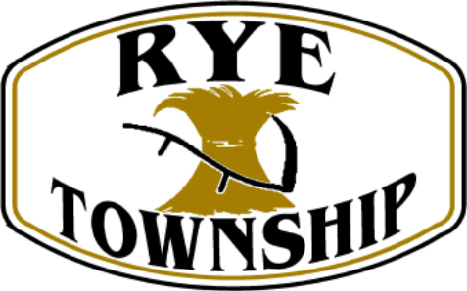

**Meeting Agenda**

**May 7, 2024**

# Call Meeting to order

1. **Approve the minutes of the April 2, 2024 meeting.**
2. **Citizen Participation:**
3. **Persons to be Heard: Clark Brothers - Regarding the development and use and access (HOP) to 1121 Valley Road, Marysville. Zoned Commercial. Former site of Floyd Crumlich’s greenhouse.**
4. **Review Subdivision Plans:**

**A. None**

1. **Review Sketch Plans**

**A. None**

1. **Correspondence:**

**A. None**

1. **Discussion:** 
   1. **Sale of parcel of land off Tower Road - >311 acres. Zoned Conservation Forest, (CF). Minimum lots of 10 acres. Steep slope lots - 15 acres. Septic testing completed by SEO. Land begins at Marysville Borough and heads west to Tower Road. Wooded lots. Mountain ground. Steep slopes. Potential Subdivision of lots.**

**Next meeting is Tuesday, June 4, 2024, 7:30 PM**

**IX. Adjournment**